City of Stamford, CT

ERP Project

Current State Report
Author: | Chuck Williams
Version: | 1.0
Date: | February 2021

© 2021 Information Services Group, Inc. All Rights Reserved.
Proprietary and Confidential. No part of this document may be reproduced in any form or by any electronic or mechanical means, including information storage and retrieval devices or systems, without prior written permission from Information Services Group, Inc.

Revision History
Date | Description | Contributor
2/12/2021 | Initial version | C. Williams

Table of Contents
1 Introduction 1
1.1 Modernize the City’s financial system landscape by: 2
1.2 Improve the efficiency of administrative operations and replace departmental shadow systems by: 2
1.3 Enable better informed management analysis and decision making by: 3
1.4 Analysis Overview 3
2 Analysis Findings 5
2.1 Current Financial System Processes 5
2.2 Departmental Operational Systems 6
2.2.1 Integration of Departmental Systems 6
2.2.2 Replacement of Departmental Systems 7

Introduction
The City of Stamford has undertaken a project to acquire and implement a new ERP / Financial system. The first step in the project was to hire ISG to provide project management and leadership. Once selected, Chuck Williams from ISG was assigned as project manager and conducted the following current state analysis.
In this process, ISG has 2 types of meetings and 2 rounds of meetings for each type. The first type of meetings are with the central office business owners and the second is with departments affected by the financial system.
ISG documents the current financial system and the systems that currently interface or could interface with it. The intent of this process is to:
- Identify current process issues, software/data redundancy, risk exposures and other concerns;
- Identify potential process improvement opportunities that could be achieved through the implementation of business processes based on best practices; and
- Identify potential barriers and constraints that would need to change to achieve process improvements (e.g., policies, statutes, laws, regulations).
In conducting this assessment, ISG performed an overall analysis of the capabilities of the administrative systems within the scope of this effort, including:
- Strengths and weaknesses;
- Risk exposures;
- Processes currently being supported by each system;
- Functionality not being provided;
- Desired features/attributes for the new ERP system; and
- Potential process-improvements
- A series of on-site meetings with representatives from the Department of Administration and the City’s other departments including the key stakeholders, subject matter experts (SMEs) and technologists that support each system,
  - The initial round of meetings focuses on the current environment, including business processes, and how the current systems support the current processes.
  - The initial group sessions, in part, focused on capturing the perceptions of end users (information users [managers and supervisors] and transaction users) of the legacy administrative systems in a number of areas, including (but not limited to):
    - Sufficiency of system functionality to enable users to perform their jobs efficiently and effectively,
    - Specific system deficiencies,
    - User friendliness of current systems / processes;
    - Ideas for improving the systems / processes;
    - Expectations for the new ERP system;
    - Potential integrations between City systems and the new ERP system
    - Timeliness of needed software changes;
    - Compliance issues, if any;
    - System availability and reliability; and
    - Risks.
The Current State Analysis tells us where the City is today in terms of systems used to conduct day-to-day business, the process used to collect, input and approve transactions in the systems, and how the systems interact with each other (integration).
In conducting this analysis, ISG followed the standard ISG process for gathering information regarding the current state of the City’s systems and processes keeping in mind the following goals and objectives:

Modernize the City’s financial system landscape by:
- Implementing a modern solution that is a common city-wide platform;
- Replace aging current software;
- Implementing a user-friendly intuitive system;
- Taking advantage of continuing advancements in functionality and technology that would enable future improvements in business and administrative practices;
- Eliminating business continuity failure and compliance risk associated with continued operation of aging financial processes and systems;
- Deploying modern, effective, and efficient financial services based on industry best practices to support the City as it grows;
- Providing scalability / flexibility to expand implemented modules / users over time; and,
- Leapfrogging traditional systems deployed over the last 30 years to a modern and nimble, system focused on business process design.

Improve the efficiency of administrative operations and replace departmental shadow systems by:
- Accelerating transaction processing time and increasing transaction accuracy;
- Enabling department users to enter transactions directly into the financial system and to attach scanned documents;
- Replacing inefficient paper-based processes with intuitive online and rules-based workflow and approvals;
- Consistently enforcing City-wide business rules to reduce errors; and,
- Empower users to perform critical work in a modern way.

Enable better informed management analysis and decision making by:
- Supporting the consistent implementation of City-wide program budgeting and accounting across organizational boundaries
- Enabling better analysis of trends, fiscal data, and program data through ad hoc reporting capabilities
- Expanding and simplifying management access to detailed information;
- Enabling real time analytics to support daily operations of the City at all levels; and,
- Improving fiscal accountability for all stakeholders.

Analysis Overview
During the first few weeks of the City of Stamford ERP Project, ISG met with the various components of the department of Administration including, Controller, Purchasing, the Office of Policy Management, Accounts Payable and Cash Management. We also met with Human Resources and the Board of Education. The purpose of the meetings was to become familiar with current systems and business processes.
During the current state meetings, the following overall goals and objectives were discussed with various attendees:
- Much of the current workflow is manual, so the ability to build workflow and approval rules that enable the City to work with as little paper as possible and process transactions in a timelier manner is strongly desired
- There are many departmental “solutions” with very little integration, having the ability to process transactions that are uploaded from Excel is important
- Having tool(s) that facilitate the creation of the City’s CAFR will save time and enable the City to issue the CAFR in a timelier manner
- The ability to attach scanned documents to transactions at the point of entry will enable the City to decentralize the scanning currently done in the Controller’s office and distribute the effort across the City thereby avoiding bottle necks in the Controller’s office
- The City would like to be able to budget for and report the costs of programs / activities in which the City’s departments engage every day enabling the ability to make funding decisions and plan and execute City services from a cross-department perspective for like types of work
- The ability to use a Business Intelligence tool to create dashboards and reports using data integrated from the ERP system and to download data into Excel or other MS tools without intermediary steps

Analysis Findings
ISG met with the members of the Department of Administration for the following Business functions:
- General Ledger | - Cash and Bank Management | - Property Assessment
- Purchasing | - Cashiering
- Accounts Payable | - Grants Office
- Budgeting | - Tax Collection
In addition, Josie Carpanzano from The Mayor’s Office and ISG met with representatives from the following City departments:
- Board of Education | - Facilities and Park Management | - Emergency Communications
- Police | - Fleet Maintenance | - Department of Health
- Fire | - Land Use | - Social Services
- Buildings | - Leisure Services | - Water Pollution Control Authority
- Building Maintenance | - Road Maintenance
- Engineering | - Solid Waste

Current Financial System Processes
Without exception, we found that procedures set by the Controller’s Office are being followed by the departments and the BOE. However, there is a very high degree of manual transaction processing and varying degrees of decentralized transaction input into H.T.E. The manual processing causes significant delays in transactions being posted in H.T.E. making the data in H.T.E. out of date when departments try to use H.T.E. data and leading to many departmental shadow systems.
In a general sense, when a transaction is received by a department, it is updated manually (written on the paper document) to include information needed by the Controller’s office, entered into the departmental shadow system, and forwarded to the Controller’s office for processing into H.T.E.
There are some exceptions to this process. Some departments have access to enter their vendor invoices into H.T.E. but must still complete the manual process ending with the paper document being transferred to the Controller’s Office.
Detailed process diagrams can be found in Appendix A.

Departmental Operational Systems

Integration of Departmental Systems
During the departmental meetings, we discussed the systems the departments use to conduct their mission-related day-to-day business, whether they contained financial data, how they can be integrated with the new ERP system, and integration points with other systems departments use to conduct their mission-related day-to-day business. The diagram below, depicts the current integration plan for the new ERP system:
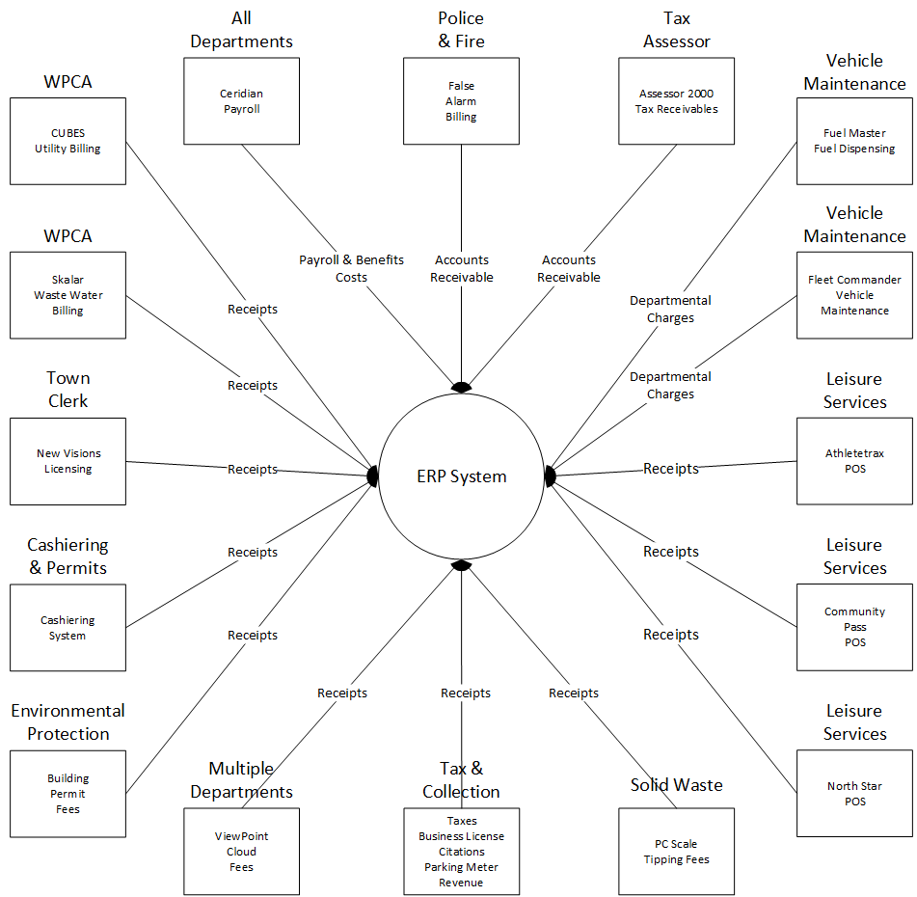
City of Stamford ERP Integration Plan

As can be seen in the diagram, the majority of the integrations will be to record payments to the City by cash, check, or credit card. There will be a Payroll system interface to record personnel costs and interfaces to record Vehicle Maintenance charge backs and other costs.
In addition to the systems noted in the diagram, a new Lease Management System that will facilitate the City’s compliance with GASB 87 will be implemented by the time the ERP system is in operation and will be integrated with the ERP system for journal entry and payment transactions.
In the current state, all of the systems shown in the diagram exist today. The difference is that “integration” between them and H.T.E. is non-existent. The manual processes result in the related data being posted in H.T.E.

Replacement of Departmental Systems
In addition to the system that can be integrated with the new ERP system, there are several current departmental systems that the ERP system will likely replace, including:
- Department Budget to Actuals Spreadsheets
- Grants Management Database
- OPM Operating and Capital Budget Databases

Major City Business Processes
The majority of transactions processed by City departments that flow into H.T.E. are Accounts Payable (AP) for vendor payments (outgoing) and Cash Management for citizen, tax, and other payments (incoming). Each of these is described below with identification of potential process improvements:

Functional Area: Accounts Payable as-is Business Process Description
Process Steps by User
Department User | Manual / System | Candidate for Optimization  (Y or N) | Optimization Discussion
Vendor submits invoice: |  |  | Many of the manual steps involved in the department process can be automated or eliminated.
- Finds related PO in H.T.E. and writes PO number on the invoice. | Manual | Y | If the department entered the invoice into the new system when they receive it from the vendor, the system can perform the matching of the PO and receipt of goods and tell them whether there is a match.
- Determines if the goods or services being billed by the vendor have been received essentially performing a matching of the PO and receipt of goods. | Manual | Y
- If invoice is rejected in the departmental approval process it is held for further review. | Manual | Y | The approval process can be managed within the new system such that when the invoice is entered, it can be submitted into workflow and the approvers can be notified by the system that an invoice needs their attention. The systems have functionality to enable approvals to be applied outside of City offices which will improve the process by not having to wait for a physical signature. If it is rejected, the responsible person can review it online, drill into related documents and attachments, and take the appropriate action. If it is approved, the system will notify the next approver that attention is needed. The next user may be another department approver or Accounts Payable.
- If Invoice is approved, enters invoice data into their local shadow system. | Manual | Y
- Physically attaches any related documentation sends invoice to Accounts Payable. | Manual | Y | Since the invoice will be entered in the department and the attachments were scanned and attached to the electronic document, this step can be eliminated.
Accounts Payable
Department submits invoice:
- Receives the hard copy invoice and any attachments and checks the PO to ensure the reference written on the invoice is correct and performs a 2nd manual matching of the PO and receipt of goods. | Manual | Y | Since the invoice will be entered in the department, the attachments will be scanned and attached to the electronic document, and the system performed the 3-way match, this step can be eliminated.
- If the invoice is rejected during matching of the PO and receipt of goods, it may be further reviewed or sent back to the department for additional review. | Manual | Y | If the matching of the PO and receipt of goods is performed by the system when the department when the invoice is entered, it will not have been submitted for department approval if there are errors eliminating the need for AP staff to perform this task.
- Enters the invoice into H.T.E. (if not entered by the departments). | System | Y | With the new system, if departments enter all of their invoices themselves, the AP staff will no longer need to complete the data entry step.
- Approves and releases document groups in H.T.E. to be paid. | System | N | Some form of this step will be included with any system selected. However, there will be parameters that can be set to automate much of it.
- System processes payments. | System | N | All systems will do this.
- When payments are produced, separates check and ACH payments. Checks are mailed to vendors and the ACH file is sent to the bank. | Manual | Y | Any system we select will print checks and create separate ACH payment files so this step can be eliminated.
- Scans the document and the invoice into OptiView for long-term documentation storage. | Manual | Y | When scanning is done by the departments. AP will no longer need to perform this step. This is a major bottleneck currently and can be eliminated.

<

